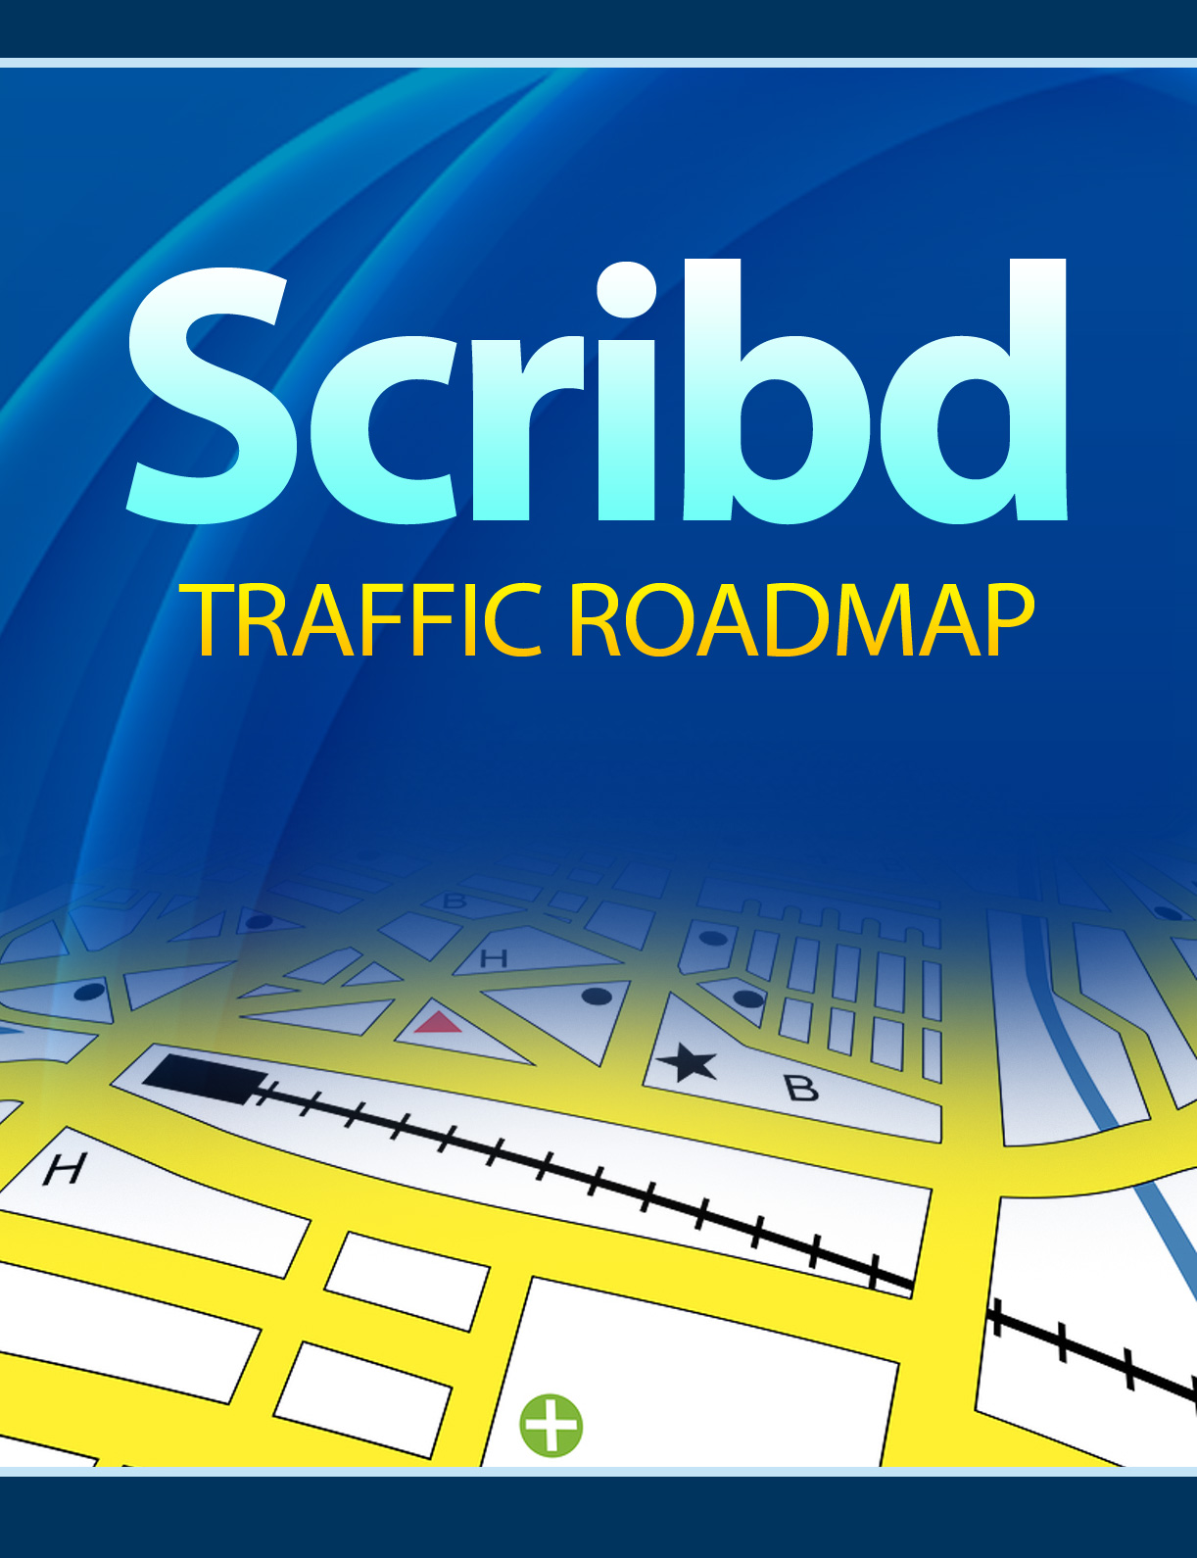

Scribd Traffic Roadmap

Brought To You By:

-8-YourName-8-
-8-YourWebsiteURL-8-

Table Of Contents

Table Of Contents 3
Section I: Meet the Real Scribd 4
The Truth about Scribd Traffic 5
What does Scribd Do? 8
Who Actually Uses Scribd? 9
Who Else Uses Scribd? 10
Ways of Getting Known on Scribd 11
Section II: Your Scribd Strategy Session 17
Your 7 Steps to Scribd Success 18
Making the Most of your Profile 19
The “Explore” Page 20
What Not To Do 23
Rights and Copyright 24
Document Handling 25
Scribd and Support 26
Section III: Peeling the Onion - More Detailed Strategy 27
1. Scribd Article Marketing 27
2. Uploading Templates for your Subscribers to Use 29
3. .PDF eBook or Report 30
4. .TXT Article Skeletons 31
5. Questionnaires and Surveys 31
6. Tip Sheets 32
7. Power Point Presentations 33
8. Newsletters 34
The Secret of Scribd Headlines 35
A Crucial Traffic Key You Should Never Overlook for a Second 37
Scribd Mobile 38
Scribd Store 39
Tracking and Statistics 40
Desktop Bulk Uploader 40

Section I: Meet the Real Scribd

You’ve decided to give Scribd a whirl… but you don’t want to be floundering around, trying to figure out the best way to use this powerful social networking/publishing platform while others rush past you. What you need is a “roadmap” – something to help you navigate not only Scribd’s own often-conflicting rules and regulations, but all the misinformation floating around the net.

In other words, you want it to fast-track you on your way to generating serious traffic.

That’s what you’re going to find here.

But first, let’s make sure your map is accurate, containing the most up-to-date information. The most direct route to a destination is not the only benefits roadmaps offer – they also point out natural and man-made obstacles, as well as dangers, pitfalls and alternate routes.

So let’s not rush to embrace the usual optimistic traffic hype you read on many blogs and in various self-anointed guides: Before you invest time in this particular marketing strategy, we’ll take time to examine some of the myths about Scribd and acquaint you with its unique advantages.

The Truth about Scribd Traffic

The first thing you need to know about Scribd traffic: It doesn’t cater to the usual SEO patterns and algorithms. In fact, during 2009, Scribd deliberately and voluntarily did something no other major social networking site has ever done before – it killed 50% of its own traffic, according to an article by Techcrunch.com.

There has been much speculation as to why any company would deliberately do this. There are several reasons, but in major part, this move came as a response to Scribd realizing that a huge portion of its traffic was due to pirated works in print – works by literary giants such as J. R. R. Tolkien, Ken Follett and J. K. Rowling. In fact, CEO Trip Adler acknowledged this when he admitted Scribd was “toning down its SEO efforts and further reducing pirated content.” While they were busy ruthlessly discouraging traffic, Scribd also instituted a new database of published works, to ensure the problem of piracy eventually disappears – all new works will be checked against the database, which Scribd admits is growing daily.

The massive Summer 2009 traffic loss didn’t appear to concern Scribd, apparently wisely looking towards long-term goals; and their confidence now seems justified. Current Quantcast.com analysis shows their traffic easily surpassing the 5 million at its height last spring – before the “crackdown”.

And that’s without the benefit of J. K. Rowling’s pirated Harry Potter-related content.

The recovery can clearly be seen Scribd’s Quantcast graph, current as of this writing, February 2010. (Quantcast also gives an intriguing glimpse of Scribd’s U.S. demographic):

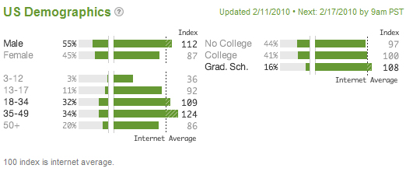

Translated, it means its strongest demographic is:

- 55% male, with the 18-49 age group, and those who have attended Grad. School, comprising more than the average share of its users

This is a screenshot of its daily traffic:
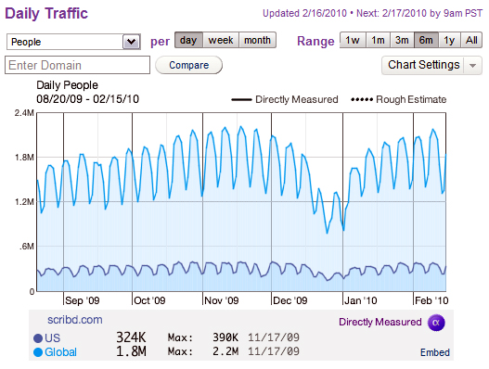

During the Techcrunch interview, CEO Adler commented that the 2009 dip was also due to a natural traffic loss during the summer months, citing YouTube and Google Books as suffering the same fate.
What should be really interesting to internet marketers, however, is the deliberate reduction of “aggressive SEO strategies” (and if you scrutinize searches inputting earlier Scribd documents, there’s some suggestion they may have started out with “Black Hat” methods – ones which they now wish to abandon). It does strongly indicate that Scribd is putting its money where its mouth is, and focusing all its efforts towards strong natural, organic traffic, as well as towards attracting traffic in a more natural, word-of-mouth way.
In other words, it’s jumping on the “buzz” bandwagon, and linking with social networks to generate a major portion of its traffic… Which is good news for anyone who does not want to be left behind this tsunami of new SEO. (Even Google tried – disastrously, some say – to jump on the “buzz” bandwagon with its much-despised Google Buzz. Unlike Google, however, Scribd allows you to control which pieces of personal information you’d like to share.)
Still, as Techcrunch.com pointed out a few months ago, Quantcast has ranked Scribd as #130 in its “most visited” category – which is enough to serve notice to the top 3 social networks that they have a serious rival.

What does Scribd Do?
Will it ever replace Facebook? Not likely. The primary purpose of the two social networking sites are not in direct competition: Rather, they compliment each other. Facebook deals mostly with App sharing buzz and chatting, whereas Scribd dispenses and shares published documents and Power Point presentations.
In other words, Facebook and Twitter are the ideal arenas in which to drive traffic to your Scribd documents… and vice versa!
So if you are planning to:
- Sell eBooks
- Boost your web presence through article marketing
- Establish your status as an expert
- Boost your own traffic
Here is a wonderful, ready-made way to attract a segment of your own unique target audience who may be missing you altogether through your traditional SEO.
All you need to get started is a juicy, original article or one viral product.
For viral, think “interesting”. This shouldn’t be rocket science – nor should it strain your brain. Documents that quickly make it to the top of the “recommended” heap and which explode in popularity are often ones with simple premises, such as “101 Valentine Ideas”.
But there is one single prohibition you need to strictly and rigorously observe…
- You cannot use PLR, Master Resale Rights or Resell rights products
Scribd isn’t kidding around when it says that it is looking for 100% original material, and will remove anything that smacks of PLR quicker than they removed J. K. Rowling’s works.

Who Actually Uses Scribd?
One of Scribd’s big advantages is its vast paid and free marketplaces. While it’s always good to specifically target a niche, one thing that’s rarely spoken about but often happens involves people missing a whole sub-group of their demographic... simply because they don’t realize it exists.
It’s possible to focus tightly on the members of a specific forum, and do accurate, meticulous market research as to where your ideal customer can be found… and completely miss a whole other market segment “hidden” outside your usual market research avenues.
These are the ones who often “discover” your document on Scribd – and once discovered it is quickly tweeted, buzzed, stumbled, digged, friended and generally passed around by all those wonderful social-recommendation means. In short, a remarkably effective way to go “viral”.
Is it counting on the element of chance?
You bet. But have you got the element of chance covered anywhere else in your careful marketing plans?
And the sudden, instantaneous swell in traffic “lucking on” to a group produces is the most surprising and delightful side effect reported, among those who upload regularly to Scribd.

Who Else Uses Scribd?
All sorts of individuals, companies, groups, educational institutions, government departments, non-profit groups, publishing companies and clubs.
Here are just a few of the most prominent:
- Ford Motor Company
- Fox Business
- Harvard University Press
- Lonely Planet
- Publishing giants, Simon & Schuster
- Random House Publishing
- The New York Times Dealbook
- The World Bank
- Wessex Archaeology
- Wiley (publishers of the “For Dummies” books)
- World Economic Forum

Ways of Getting Known on Scribd

Popular, best-selling authors go to great trouble not to have their published works appear on public platforms. For most marketers, however, the wish is quite the opposite: We’re here for the traffic opportunities and the exposure.

Scribd provides a perfect vehicle, since it is a recognized authority site, with an Alexa traffic rank today, as of this writing, at 246.

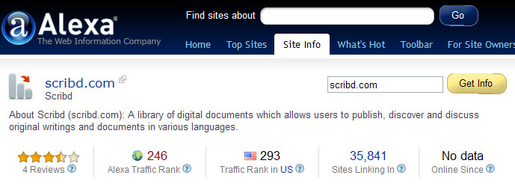
How can you get yourself known on Scribd, when you’re not exactly J. K. Rowling? We’ll go into the specific ways in more detail shortly, but here’s a brief overview:

Branding – brand not only traditional documents but also your company literature (brochures and flyers) via Scribd.

Newsletter Publishing – Publishing your newsletter on Scribd as well as providing it to your list has proven to be a major traffic generator for many online entrepreneurs.

Resource Sharing – Allowing Scribd subscribers to find and use your company’s tip sheets, templates and “how to” guides is another priceless way to create buzz and increase your traffic.

Search Engines – You don’t have to lift a finger: Search engines index Scribd daily, with all the new content being added. Take advantage of that 246 Alexa page ranking and don’t be afraid to share.

Social Network Opportunities – The moment you sign up, you’re able to link your Scribd activity to your Twitter and Facebook accounts. Don’t underestimate the power of social buzz – the new “search algorithm” of this brand new decade.

Backlinks – links to your site from an authority site such as Scribd is yet another natural traffic booster.

Embedding Documents – Embedding documents you’ve uploaded to Scribd on your blog is a natural and organic way to leverage Scribd’s massive visibility and traffic. And it doesn’t matter what file type the document was created in: All you have to do is click the “Share and Embed” tab, and you are instantly supplied with a simple snippet of code to insert on your website. This gives you double the exposure – and those powerful backlinks.

Pre-qualifying Traffic – Much has been written on the subject of how you can “pre-qualify” your traffic. The result is often a tendency not to think of the flip side of that particular coin – the advantages of reaching a huge, generic audience. While it’s true that your little document may not catch on mainstream wildfire, you may actually be missing “invisible” streams of pre-qualified traffic you don’t even realize exist. Scribd allows them to find you, by searching with their own criteria and keywords (the ones you may not have realized existed).

Selling your Works on Scribd’s Online Store – This marketplace, which makes documents easy to access for almost every computer, mobile device and operating system (OS), offers yet another arena in which to profit directly from your created content.

Sales Stats Analysis – Another benefit Scribd provides is the ability to speedily access and analyze your sales stats for its online store. Having this information at your fingertips can help you fine-tune your documents to reach your target market in an even more focused manner. Paying attention to this brings targeted traffic – and that’s the kind that really counts, if you’re using the internet as a source of income.
Reads and Ratings – Each document also lists how many reads it has generated, and provides the opportunity for people to rate it. Providing quality will quickly help your stats reflect social proof in the results.

Trending – On Scribd’s main “Explore” page, there’s a left-hand side “Trending” column, featuring documents dealing with what’s currently hot. Get into the habit of paying attention to it and, if you can, quickly creating your own document, based on one of the Trending topics currently displayed.

Topics range from the eternally popular, such as “Weight Loss”, to the most transient (“Toyota” – all relating to the recent Toyota recalls).

Scribd also provides a sidebar to your document that contains the categories:

- Related
- More From This User
- Featured on Scribd

It’s to your advantage to provide your readers with “More From This User” as quickly as possible, to minimize any impact from “Related” competitors.

(On the other hand, being lumped into the “Related” category yourself will help you even things out with any competitors!)

A further boost for generating traffic via Scribd: This month (February 2010) The Huffington Post introduced a new feature column, Scribd Editor’s Pick. Its purpose is to showcase new or lesser-known authors of merit.
One final reason to invest your valuable time in Scribd: Not only is it a great place for you to showcase your own writings and presentations, but it’s a great research resource for you!

“But What if I’m Not A Writer?”
There are two simple ways over this seemingly-impenetrable wall – one of which is already in place for you:
- Use a ghostwriter to create original content for you
- By its own admission, Scribd doesn’t use any form of qualification. There is no waiting for approval, once you upload and share a document. Items seem to get removed only after someone makes a complaint or points out the infraction; or have been uploaded with aggressive black hat SEO techniques set in place… so removals seem to be based on complaints rather than rigorous screening and long waiting
The average honest marketer need not worry – as long he is not using any sort of previously written content and claiming it as his own.
In the next section, we’ll focus on the best Scribd strategy for you…

Section II: Your Scribd Strategy Session
The best strategy for Scribd success is to appear not to have one. Scribd has repeatedly pointed out, since Trip Adler announced the changes, that anything smacking of deliberate strategy and sales is going to get you swiftly banned – particularly if you indulge blatantly in “affiliate marketing” and “SEO”, which they seem to regard as a cross between pornography and devil-worship (along with “health care products”).
Think I’m exaggerating? Check out their own FAQ…
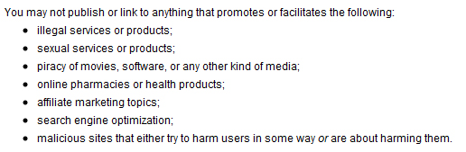
(In fact, that particular page is a “must-read”, because it also gives you specific prohibitions and allowed activity for self-promoting and advertising too.)
It helps to understand the bigger picture: When Scribd is lumping affiliate marketing topics, search engine optimization and health products in with illegal services and malicious sites, what it is really protesting about are the very things most marketers don’t want either – “Black Hat” SEO techniques, malware, and anything that would lessen Scribd’s credibility as an entity and authority body.
(Meanwhile, as of this date, J. R. R. Tolkien’s “The Hobbit” is still available for free download).
Your best defense against getting bumped off Scribd?
Don’t do anything “shady”.
And keep it simple.

Your 7 Steps to Scribd Success
Here is what you are going to do, to bring your web presence to life at Scribd…
1. Your Profile – Create a simple profile that will tell people:
- Who you are
- What you do
- What you like
- Your URL and any other contact info, including your phone number
2. Your Photo - Including your photo does help people “connect” with you on social media like this
3. Link your Scribd Account to other social networks (such as Facebook and Twitter), so that your “scribbles” automatically appear
4. Find people to whom you wish to subscribe.
5. Upload a document.
6. Create a Scribble (the equivalent of a wall post in Facebook, or tweet on Twitter).
7. Retrieve one of your graphic badges that have already been created for you, and insert the code into your websites or blogs.
That’s it! (And you can edit or update your settings at any time, simply by clicking on “Settings” in the top right corner of your main Scribd page.)
But there’s one final step you need to take… and that is to “pencil” or include your Scribd activity into your business plan or promotion strategy.
Make it a regular deal – Scribd likes people who are consistent in their habits (particularly when they upload documents regularly).
“Regular” authors are far more likely to be featured as one of the “suggested” people to subscribe to, when new Scribd members sign up.

Making the Most of your Profile
Don’t just put things like: “ Likes cats” or “no time to read” in your profile – use it instantly create interest by publicizing the document you should already have ready to upload.
There are a couple of places in your profile where you can quite easily input information such as: “Just uploaded 31 Steps to Romantic Success, or whatever your dazzling document is called.
Make yourself interesting. If humor is your specialty, upload a funny photo instead of the usual mug shot. Scribble a “joke of the day”.
If your area of interest is freelance writing, upload your most outrageous or off-the-wall article, and put “Author of 41 Uses for a Stuffed Turkey” (or whatever your latest masterpiece is called) in your Profile.
And yes – the profile settings allow you to link to your main website.
Remember that although it’s primarily a document sharing site – a virtual “world library” – it’s also a social networking site, so make time to network! Providing you’re not driving people straight to a sales page, it’s a wonderful alternate vehicle for your marketing strategy.
And it is also a community. Share and contribute… and watch your network (and downloads grow).

The “Explore” Page

Let’s literally take a look at how this works out, in getting your work “discovered” by the general community. This is what the a chunk of a typical Scribd “Explore” page looks like:

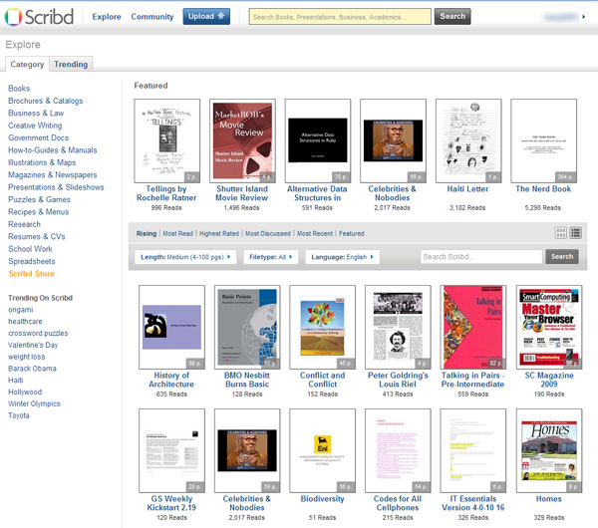

(TRAFFIC HINT: Make sure you have a strong Cover Page for these thumbnails!)

Here, you can instantly see all the categories and trends, as well as – if you look more closely – what’s “Rising”, “Most Read”, “Highest Rated”, “Most Discussed”, “Most Recent” and “Featured” – simple buzz (and traffic) creating tabs Scribd readers rapidly learn to depend on.

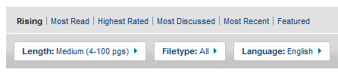

And as you can see by the headings below these tabs, people can select the length, file type and language of documents they wish to read, too. So take all that into account, when planning your Scribd traffic strategy.

All these categories, criteria and sub-groups end up creating a lot of places for your document to gain exposure!

The Million-Dollar Question
Of course, there’s more to becoming successful with Scribd. There are tips, tricks, and things you need to know not to do in order to help yourself rise quickly through the ranks.
And then there are side benefits that can bring you enormous traffic, such as recently-announced plans for an official Scribd Mobile and Scribd’s online store. And all this is covered under the million-dollar question: “Exactly how do you use Scribd to boost your web sales?”
Think outside the box. Discard all the old stale internet marketing ideas, and see what you can come up with. What Scribd offers is flexibility – and the choice for your reader to decide whether or not he or she wants to read your document online… or download it.
That goes for you too: Paid… or freebie. Your choice.
8 ways to effectively use Scribd include uploading:
- Your best articles
- Excel spreadsheet templates to help your market
- .PDF ebook or report, of course
- .TXT article skeleton (Be careful with this one: Just don’t call it `PLR’!)
- Questionnaires and Surveys
- Tip Sheets
- Power Point Presentation (you can link to it from your blog)
- Newsletters
Read through Scribd’s impressively thorough Support section: Although there are specific restrictions, there is a lot of leeway for creative thinking, too.

What Not To Do
Scribd does have its limitations and drawbacks. For example, its store is only “open” (for both buying and selling) to residents of the United States – even Canada is excluded. It also takes credit cards only as its payment processing method – No PayPal yet.
I’ve mentioned things you shouldn’t do a couple of times. To recap, here they all are in one handy list:
- Do not use or sell PLR, Resell Rights or Master Resale Rights
- Do not distribute material to which you do not own the copyright (that includes public domain material)
- Do not use Scribd content for any commercial purpose (that includes public domain material that might have slipped past them into the download area)
- You cannot make unsolicited promotions or offers, nor use blatant adds for the purpose of revenue generation
- People outside the U.S. cannot yet sell or buy from Scribd’s online store
- PayPal is not yet a payment option – credit card only
- No one under 13 can register (surprise, surprise)
- You cannot use URL shortening services to generate your links (specifically mentioned: TinyURL, bit.ly)
- You may not sell public domain works (though legal elsewhere, it’s strictly forbidden on Scribd)
And don’t forget those SEO, affiliate marketing and “health product” prohibitions too!

Rights and Copyright
Although under U. S. law, your works are already automatically copyright, there is one important fact about Scribd you need to know. Documents uploaded to Scribd default to a Creative Commons Attribution/Non-Commercial license, the instant they are uploaded.
What is a “Creative Commons” license? Generally, you still retain copyright, but allow some limited use under certain conditions – the conditions usually being set by you. In this case, Scribd has specified the conditions.
Can I change it? Sure you can. If you want full control over your copyright, just click on the document’s “Edit” panel, and remove the Creative Commons license.

Document Handling
One of Scribd’s biggest advantages is the way it can handle multiple types of document formats, thanks to its own unique iPaper system.
Create your document in your favorite processor, on your favorite computer, with its own unique operating system. Then upload.
It’s as simple as that.

Scribd and Support
This is an example of how user-friendly Scribd is. Steps are always suggested, and its function follows many other commercial applications web users are familiar with, so there is no huge learning curve. Support is always a click away in their impressively easy-to-read (and what’s more, easy to find) Support section; and if they haven’t got an answer there for your specific question, you can easily submit it to a real, live Support rep (without having to go through hoops, remembering passwords, logging into anything – you’re already logged onto Scribd – or such time wasting nonsense that you’ve probably seen with certain marketers’ “help desks”).
In fact, I submitted my own question, the other day; and got a personal, helpful reply within the same day.

Section III: Peeling the Onion - More Detailed Strategy
Now that we’ve got some of the mechanics out the way, lets return to our “8 ways to most effectively use Scribd”, and zoom in a little more closely on each suggestion…

1. Scribd Article Marketing
Given all the prohibitions, is it worth article marketing on Scribd?
Some of Scribd’s unique advantages, when it comes to article marketing:
- You are now able to place links within the body text of each article
- You are able to create your own, custom resource box (complete with pictures) and insert it at the end of your article – providing it doesn’t link to “spam”
- You can include photographs, illustrations and graphics
- You can give your article a cover page (and you should!)
- Among all the other formats, you can upload your article as an .RTF, .DOC (or .DOCX) file, and include a clause encouraging people to place or embed it on their websites (with credit to your URL). In fact, it handles and makes readable for all even .DOCX and .MP4 files.
- You can (discreetly) optimize your article for keywords – avoid any “formula” methods, however. Focus on your content.
- You can be creative with fonts – most are rendered really well on Scribd – unlike in an HTML web format
- You are free to create a “signature look” to your articles with logos and colors
- You can include an Author Bio, if you so choose
- You are free to focus on any genre, niche, subject – except the aforementioned “affiliate marketing, health products and SEO”. (And of course anything illegal!)
On other benefit you may not have thought of: Since Scribd articles can be uploaded in any format, doing so by creating a .PDF, rather than .DOC file or HTML, instantly solves the universal question: “Will it be viewed by Google as `duplicate content’, if I place it in this directory?”
The most important thing you need to know about uploading your works – for remuneration or for free – to Scribd or its online store is Scribd copyright policies…
What If My Subject Doesn’t Fit Any Category?
Categories are broad enough and plentiful enough in Scribd that it’s rarely a problem. However, if you’re really dissatisfied with the choices available, you are encouraged to send in new category suggestions to support@scribd.com.
They do read all suggestions, and categories are updated with new ones about four or five times a year.

2. Uploading Templates for your Subscribers to Use
The beauty of this strategy – it doesn’t just serve your subscribers, but delights potential new subscribers too – the ones you didn’t know existed – when they “accidentally” come across your template among Scribd’s offerings.
You can create your “templates” in any format – Excel, .DOC and DOCX, .RTF – you name it, you can do it.
Just a few suggestions of what to provide:
- Forms they can copy and use
- Questionnaires they can use on their own sites
- “Writing” templates – article templates, blog post templates, etc.
- Tracking templates in Excel
- Data collection templates in Excel
And any other unique, original template you can dream up!

3. .PDF eBook or Report
TIP: Don’t call your report a “report” – to Scribd, that smacks of the dreaded “affiliate marketing”. Instead, call it a “White Paper” – Scribd is big on white papers.
Apart from that, the sky’s the limit. Here’s a taste of things you can upload:
- “How to” manuals and guides
- Genuine white papers
- Tip Sheets
- Reports
- Reviews
- Newsletters
- Company information
- Employee information
- Fiction
- Case studies
- Results (of questionnaires, surveys, focus groups, etc.)
- Scribbles
- Humorous pieces
- Graphics-heavy ebooks
- Power Point slideshows
- Portfolios of your work
- Resumes
- CVs
- Sheet Music

4. .TXT Article Skeletons
Again, be careful not to call this “PLR”. Publish it as an Article Skeleton or Suggested Article Outline, granting within the document rights to use it, and specifying that right is given providing it is used only as a framework and the user’s own, unique content is applied .
Those who use PLR will instantly treat it as such: Those who do not will likely think of it more as a “template” – though unlike a true template, it will contain basic, generic article material for them to build upon.
DISCLAIMER: Yes, this particular strategy might pose a risk of your being banned, if your work is deemed PLR. The whole key to not violating Scribd’s principals is to recognize and keep in mind their veto against spam. Is your article skeleton pure spam… or have you provided something really useful for a group of readers who can really get something out of it?
Remember, if you annoy people, they’ll report you. Spammers annoy. Authority experts help.

5. Questionnaires and Surveys
These can take 2 forms:
- You’re sharing the results of specific questionnaires or surveys
- You’re offering questionnaires and surveys for people to copy into their own websites
Either way, it’s a win-win situation – if in your zeal to comply with Scribd’s regulations, you haven’t lost sight of the eternal key marketing questions:
- What’s in this for my reader? Why would he want to read it?
- What problems am I solving for him?
- What fabulously helpful act is being performed here for his benefit?
The safest and simplest ways to use questionnaires and surveys here is as “sample” surveys, or “sample” questionnaires.
People appreciate having a real, working example to look at, when creating their own questionnaires and surveys. (You can add a Tip Sheet at the end of the sample, for even more reader gratitude – and relief. Or upload one separately.)

6. Tip Sheets
These are enormously popular – and a great way to make yourself quickly known on Scribd, because they are easy to produce. You can basically sit down and write one in half an hour, if you’re an expert on a particular subject.
Go one step further, however, and “brand” your tip sheets – by always, consistently using the same graphic layout, fonts and format. You can also use:
- The same logo
- The same title Prefix
- The same colors
- A “signature” graphic
- Your “signature” signature (perhaps with photo)
People will soon get to look out for your Tip Sheets, if you can give real value. Branding them with a consistent format and look will help establish them (and you) in mind as an authority.

7. Power Point Presentations
You can provide links from your websites or blogs directly to your Power Point presentations, just as you can with YouTube; but whereas a Power Point presentation can often seem rather lame on YouTube – where your competition is utilizing live action, video effects, music and real animation – it can feel surprisingly punchy amid all the static text documents of Scribd.
A Power Point presentation allows you to quickly convey data that would otherwise be dry, in text format, and appeal to that segment of your target market who perceives things primarily visually, rather than by hearing or reading data. And you can simply and easily prepare your Power Point for upload – for free – by visiting Drawloop.com (which also allows you to handle other document types, too. In fact, you can combine them all together, to create a simple, single Flash document).
These suggestions are just the bare bones of what you can do. Brand your articles, as well as tip sheets. Brand your eBooks, templates and Power Point presentations.
Create your white papers and eBooks to be read on mobile readers. It’s easy, with Scribd.

8. Newsletters
One area you definitely shouldn’t overlook is the chance to regularly schedule and upload your newsletter (Scribd loves “magazines”!).
It can be a real pain to prepare your newsletter in HTML for upload to autoresponders such as iContact or GetsResponse. A far simpler way is to create it using whatever document and graphic editors you find easiest to use, make it look dazzling, brand it with your logo, graphics or colors – and upload it to Scribd, where you will have instant stats, the moment anyone starts reading it.
The next step, after your newsletter is uploaded? Merely sending out a simple text autoresponder email notice to your list, directing them to your Scribd Document page.
Having a regular newsletter archived and available in Scribd’s “library” also gives you web and author credibility.

The Secret of Scribd Headlines
What can create more traffic than any other Scribd strategy? What makes or breaks a document, when you’re trying to be `discovered’ and get it ranked in the “Explore” section?
Easy. Your headline.
Create curiosity or promise unique information, and you won’t have to lift a finger to generate those clicks. But there are a few tricks to optimizing your headlines for Scribd.
First, forget everything you were ever taught about “keywords” – don’t even waste a second researching them! The curiosity factor is what gets your works read on Scribd – especially in the “Explore” section.
If you can make your headlines catchy too, all the better.
A few examples of curiosity-arousing headlines – not necessarily the most punchy and dynamic, but intriguing:
- How Not To Stand Out In Any Crowd
- When Secrets Die
- Cow Chips Aren't for Dipping
Another type of headline that works particularly well for Scribd is the simple descriptive headline. It provides:
- Instant pre-qualification
- Your promise of unique information or a problem solved
How to Easily Convert Your Microsoft Word Files to PDF is going to instantly appeal to a new marketer (or even a seasoned marketer who is curious).
Drawing Trees is going to instantly appeal to the drawing enthusiast who is having trouble with landscapes… just as Carving Facial Expressions is going to instantly appeal to representational sculptors.
To a mystery writer, something as simple as Writing Mysteries holds instant appeal. To a games/comic book aficionado, all you might need is an “insider” word such as Warhammer.
It’s not only important to state simply what your document provides, but make sure it’s a topic that appeals to your market.
If you want to rank in Scribd’s “Trending” topics section, feel free to pick a hot Trending topic that is listed, and write something on it. In the case below, the author’s name gives you more clues what his upload is really all about than does the movie:
- Shutter Island Movie Review - (Author: MarketBOB).
(This particular review has already, at time of writing, garnered 1430 reads… and if you look at its neighbours, the average document usually fetches about 400).

A Crucial Traffic Key You Should Never Overlook for a Second
No matter what type of headline you decided to use, keep in mind, however, that on the "Explore" pages, you are only allowed 2 short lines for your headline. Call it something really wordy, such as The Present Tense Between English and Arabic: A Comparitive Study, and all your potential market will see is The Present Tense Between. Those interested in the Arabic language will most likely not realize it is a topic they would be interested in, since they’re more likely to instantly assume it relates to English grammar. (An example of how powerful this text is, even with the headline mistake: It’s actually a strong niche trender anyway – but think how much more it could have been, if the word “Arabic” had actually been visible on the “Explore” page!)
Call your paper something even only as long as: Strategies to Avoid Financial Extinction, and you run the risk of seeing it listed as: Strategies to Avoid Financial.
Mind you, you can use this drawback to your advantage, if you want to incite irresistible curiosity – but you have to be shrewd about it. In the previous example, just the word “Financial” might be enough to:
- Prequalify a financial-minded readership
- Make them “turn the page” to see exactly what to avoid!
Whereas I guarantee that without that key word “Arabic”, a huge segment will not bother to find out what follows “Between” in the former example – they’ll skip over it. If anything, it will prequalify a readership interested in English grammar – who will quickly click away, when they realize it is actually an Arabic language comparison.

Scribd Mobile
The latest buzz is that Scribd intends to go mobile. In fact, in November 2008, Scribd did add a mobile site where you could read eBooks on almost any mobile device. As for accessing Scribd mobile, nothing could be easier for viewers: Most mobile devices will automatically redirect people to the mobile Scribd site, but if not, it can be easily accessed by visiting http://www.scribd.com/mobile.
What Scribd is adding – perhaps by the time this Special Report hits the stands – consists of a “send to” button, which will allow people to send content to their mobile devices.
Once this happens, it promises the opportunity and expectation of huge traffic increases.

Scribd Store
There are 2 absolutely rigid requirements at the time of this current writing, in order to be eligible to sell your works in Scribd’s digital store:
- You have to live in the United States
- Your document must be completely original
Scribd takes 20% as “consignment fee”, plus 25 cents “transaction fee” from every sale – and 40 cents if the document is embedded with any sort of DRM (digital rights management) protection. There are no other hidden fees, and digital documents sold and delivered over the internet are not taxed.

The store has some features worth noticing. You can:

- Make “real time” changes to pricing
- Access sales data and statistics
- Allow people to preview portions of your work

The other huge traffic advantage of Scribd’s online store: Your documents can be read on most eReader devices.

Tracking and Statistics

Your Scribd Online Store documents aren’t all you can track: Any document uploaded will instantly show you basic stats.

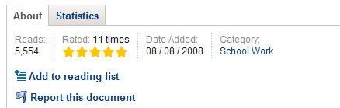

As you can see, on the actual document’s page, you get:

- The number of reads
- Its rating (out of 5 stars – including how many times it’s been rated)
- When it was added
- The category to which it belongs (sometimes helpful in assisting you to decide where to upload a document of your own

Desktop Bulk Uploader

One final, small detail…

Scribd’s desktop Bulk Uploader won’t actually increase your traffic, except in the most indirect way by providing yet another good reason why so many people have quickly become enamored of Scribd, but their bulk upload tool is worth mentioning.

It allows you to upload whole batches of documents (after a one-time, simple, quick download of the tool you’ll need) straight from your desktop – the only time you’ll have to download anything, in order to use a Scribd function).

Scribd constantly focuses on removing all obstacles from using their site and services, simplifying document sharing down to its –nth degree.
Simplicity and ease-of-use is one of the most important secrets of attracting traffic – and loyal fans. Take full advantage of Scribd, and make it work to increase your traffic!

